Two Life-changing Offers from the Lord Jesus Christ

Part I: The Bible = the story of God’s attempt to establish His kingdom on earth
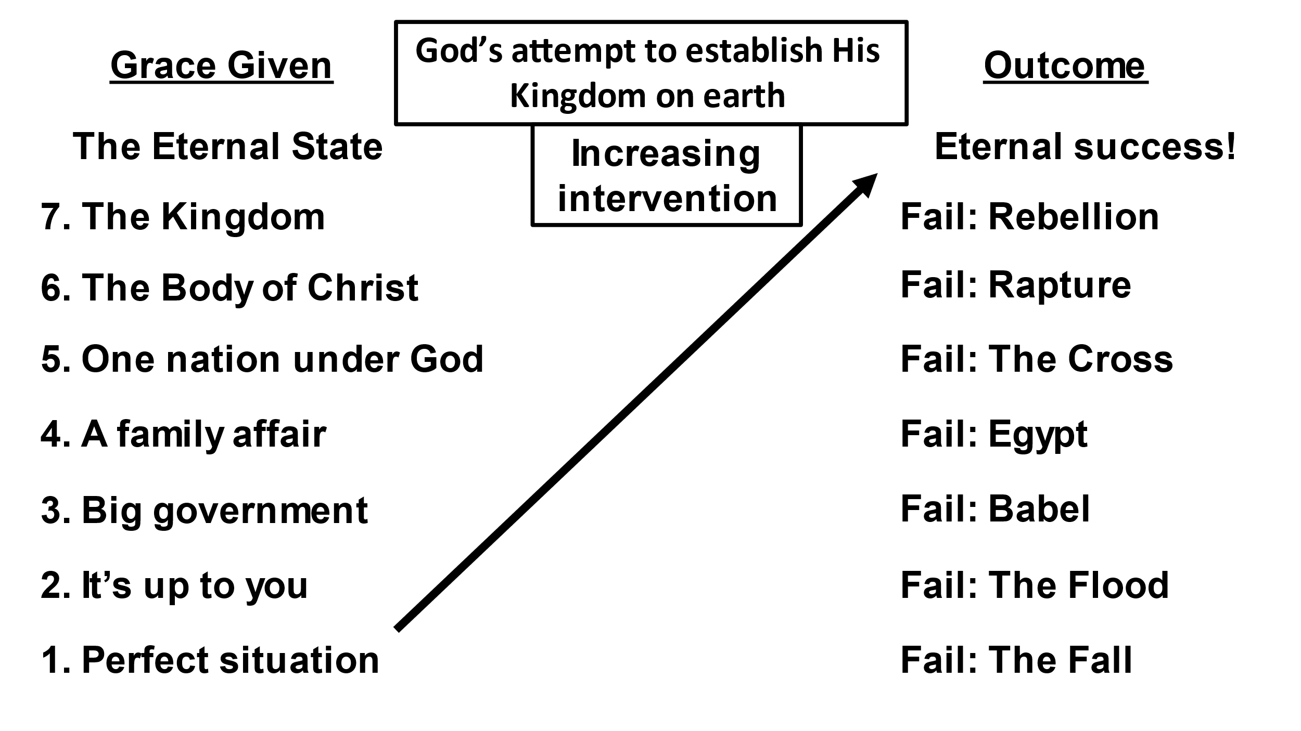

Part II: Two Offers; two salvations; eternal consequences
A. In John
1. A free gift – Rom. 6:23; Eph. 2:8-9

2. Given to those who believe – 3:14-16; 5:24; 6:47; 11:25-27
3. Consequence – 3:18
B. In Hebrews
1. By works – 5:8-9

2. Given to those who obey – 5:9

3. Consequences – 2:3-4; 3:12-14; 6:4-8; 10:26-31, 35-38
Part III: The focus of Hebrews
A. A time future to the Church Age –
- Heb. 2:5 “The world to come of which we speak”
- Heb. 1:6 – “When He again brings the Firstborn into the world…”
- Heb. 1:13 – “Sit at My right hand until I make Your enemies Your footstool”
- Heb. 1:14 – “ministering spirits…service to those who will inherit salvation”
B. A salvation future to the Church Age – Hebrews 9:28
- The purpose of His first coming = to bear the sins of many
- The second coming is:
  - Apart from sin
  - For those who eagerly wait for Him (growing believers)
  - Called “salvation”

C. For your study: The most common “salvation” in the Bible predates the Church Age = “to be delivered from one’s enemies” or simply the idea of “Victory”. The many Psalms of David prefigures His son, the Messiah. It is this salvation faithful believers are invited to in Hebrews. (2 Sam. 22:4 with Ps. 18:3; Ps. 37:40; 44:7; 106:10; 138:7; also, where the context explains it - Ps. 3:4-6; 7:1-9; 31:1-8; 54:1-3; 59:1-7; 69:1-12; 71:1-13; 110:1-14; 138:6-8 and many more).

Ruling with Jesus
Rom. 8:17-18; 2 Tim. 2:12; Rev. 2:25-27 (Matt. 20:20-28)
What’s it going to be?

